**PRACTICAL NO:10**

**CODE:**

**CREATE PROJECT IN NETBEANS**

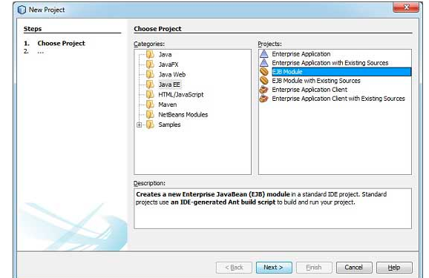

**BY CLICKING ON NEXT FOLLOW THE FURTHER STEPS**

**SET SERVER FOR PROJECT HERE JBOSS SERVER IS USED:**

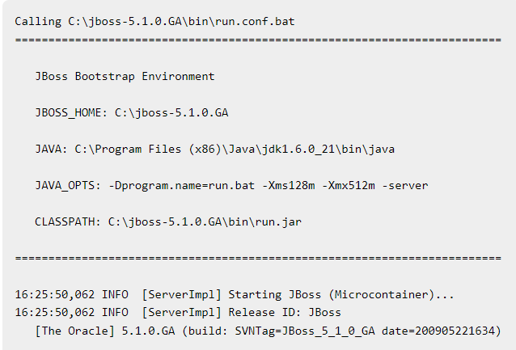

**EJBTESTER.JAVA**

package com.tutorialspoint.test;

import com.tutorialspoint.stateless.LibrarySessionBeanRemote;

import java.io.BufferedReader;

import java.io.FileInputStream;

import java.io.IOException;

import java.io.InputStreamReader;

import java.util.List;

import java.util.Properties;

import javax.naming.InitialContext;

import javax.naming.NamingException;

public class EJBTester {

BufferedReader brConsoleReader = null;

Properties props;

InitialContext ctx;

{

props = new Properties();

try {

props.load(new FileInputStream("jndi.properties"));

} catch (IOException ex) {

ex.printStackTrace();

}

try {

ctx = new InitialContext(props);

} catch (NamingException ex) {

ex.printStackTrace();

}

brConsoleReader =

new BufferedReader(new InputStreamReader(System.in));

}

public static void main(String[] args) {

EJBTester ejbTester = new EJBTester();

ejbTester.testStatelessEjb();

}

private void showGUI() {

System.out.println("**********************");

System.out.println("Welcome to Book Store");

System.out.println("**********************");

System.out.print("Options \n1. Add Book\n2. Exit \nEnter Choice: ");

}

private void testStatelessEjb() {

try {

int choice = 1;

LibrarySessionBeanRemote libraryBean =

(LibrarySessionBeanRemote)ctx.lookup("LibrarySessionBean/remote");

while (choice != 2) {

String bookName;

showGUI();

String strChoice = brConsoleReader.readLine();

choice = Integer.parseInt(strChoice);

if (choice == 1) {

System.out.print("Enter book name: ");

bookName = brConsoleReader.readLine();

libraryBean.addBook(bookName);

}else if (choice == 2) {

break;

}

}

List<String> booksList = libraryBean.getBooks();

System.out.println("Book(s) entered so far: " + booksList.size());

for (int i = 0; i < booksList.size(); ++i) {

System.out.println((i+1)+". " + booksList.get(i));

}

LibrarySessionBeanRemote libraryBean1 =

(LibrarySessionBeanRemote)ctx.lookup("LibrarySessionBean/remote");

List<String> booksList1 = libraryBean1.getBooks();

System.out.println(

"***Using second lookup to get library stateless object***");

System.out.println(

"Book(s) entered so far: " + booksList1.size());

for (int i = 0; i < booksList1.size(); ++i) {

System.out.println((i+1)+". " + booksList1.get(i));

}

} catch (Exception e) {

System.out.println(e.getMessage());

e.printStackTrace();

} finally {

try {

if(brConsoleReader !=null) {

brConsoleReader.close();

}

} catch (IOException ex) {

System.out.println(ex.getMessage());

}

}

}

}

**OUTPUT:**

